Email Etiquette
Activity

Look at the emails sent. If you were to rewrite the email, what tips could you apply to make it stronger?
-Rewrite the emails below

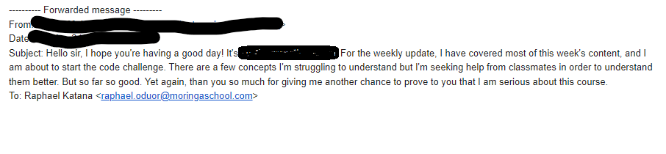

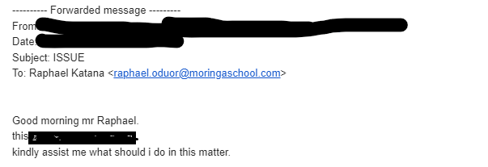

gaudent.akeyo@moringaschool.com

Question 2
In groups, draft the following 2 emails:

Write an email to your technical mentor seeking assistance in setting up for the class

Write and email to a potential mentor, seeking guidance as you go through Moringa School and as you prepare to join the job market.

ANSWERS
QUESTION 1
Tips to make the email stronger :
- Add a clear & concise subject line
- Be brief and straightforward eg; He introduced him/her self which is being repetitive
- Add a Closing

A.
Subject: Weekly Update

Dear Mr. Katana,

I hope you're having a great day. I’ve covered most of this week’s content and will soon begin the code challenge. I’m working on clarifying a few challenging concepts with the help of classmates.

Thank you again for this opportunity—I truly appreciate it.

Best regards,
Ernest Kamau,

B.
Tips to make the email stronger :
- Be brief and straightforward eg; He introduced him/her self which is being repetitive
- State the purpose of the email clearly

QUESTION 2
A.
Subject: Support Needed for Class Setup

Dear [TM Name],

I hope you're doing well. I'm experiencing some difficulties with the class setup and would appreciate your assistance. Please let me know a convenient time for guidance or any resources that could help.

Looking forward to your response.
Best regards,
Daniel Kimani

B.

Subject:Seeking Mentorship in Software Development

Dear Mr. Katana

I hope you're well. My name is Daniel Kimani and I’m currently studying software development at Moringa School. As I near the end of my studies and prepare for the job market, I’d greatly appreciate your guidance.

I admire your work in the field and would be grateful for any advice or insights you could share to help me succeed in my career. If you have time for a brief meeting I'd love

Looking forward to your response.
Best regards,
Ernest Kamau

BREAK-OUT ROOM 7 PARTICIPANTS
- Ernest Mwangi
- Mercy Maritime
- Billadams Nyamweno
- Frankincense Okwemba
- Daniel Kimani
- Joseph Kabinga
- Ryan muigei
- Joseph Ngugi
- Collins Ronoh

